**Weather API Integration with Salesforce**

**Description:** Accessing information from external source using REST API and store or display on Salesforce. We are displaying the Minimum Temperature, MaximumTemperature,  Pressure and Humidity using [https://openweathermap.org](https://openweathermap.org/) of Shipping City of the Account.

**Steps To Integration**

1. Ensure You have “API Enabled” Permission
2. Register the site in Remote Site Settings
3. Get an API key
4. Create the controller that will call the API
5. Check that the HTTP request response code is 200 (OK)
6. Deserialize JSON response code into a Map of string to Object
7. Get values you need by accessing the relevant key
8. Display using a button or an embedded VisualForce page

STEP 1:

Ensure you have “API Enabled” permission. This is a setting that allows you to make API calls.This must be enabled to call any external services.

1. Navigate to Setup>Profiles>System Administrator.
2. Ensure API Enabled is selected.

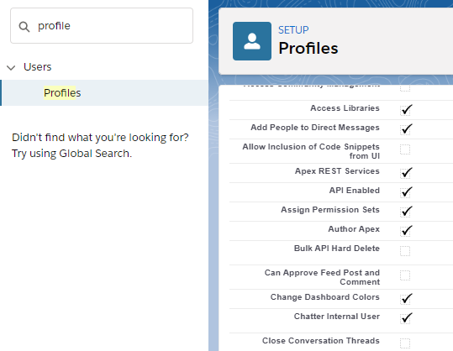

STEP 2:

Register the site [https://openweathermap.org](https://openweathermap.org/) on Remote Site Setting.

1. Navigate to Setup>Security>Remote Site Setting
2. Create a new Remote Site
3. Fill any name in “Remote Site Name” and [https://openweathermap.org](https://openweathermap.org/) in “Remote Site URL”.
4. Ensure Active is selected.

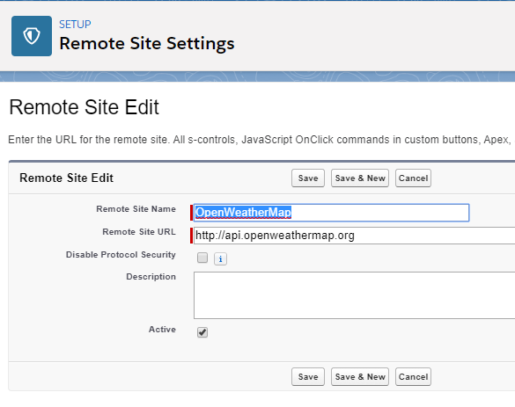

STEP 3:

Now we need to get an API key to identify ourselves,this authenticates us to the service.

1. Go to <http://openweathermap.org/api> .
2. Click on Subscribe on Weather setting that interests you.
3. For our purpose the Free package is fine.Click Get API key and Start.
4. Sign up.
5. Once completed your API Key will be shown.

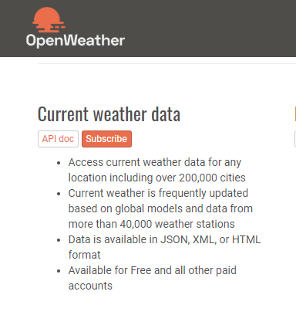

STEP 4:

Create a controller class that will call the API. We will create a Lightning Compound which gets data from the controller. We also save the API key generated in the previous step and add it to the string to be added to the end of the URL. We also take the Shipping City from the Account and add it to the URL.

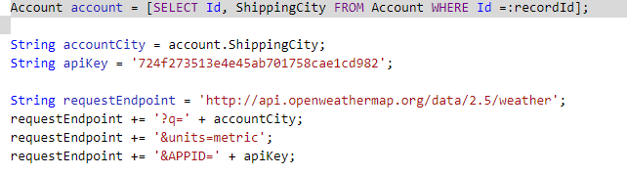

STEP 5:

To start we check that the request has been successful by checking the status code is 200,this is the standard response for successful HTTP requests.So we will now move forward with retrieving the relevant weather details from the api by querying the required object.In this case we retrieve “Main”.

Our component will now display the following details.

1. Pressure
2. Humidity
3. Minimum Temperature
4. Maximum Temperature

STEP 6:

Add the Lightning Component to Account page. Now you will be able to see the Temperature and other details of the Shipping City of the Account on its page. Further, if you change the Shipping City of any Account, the details of the component will also get updated.

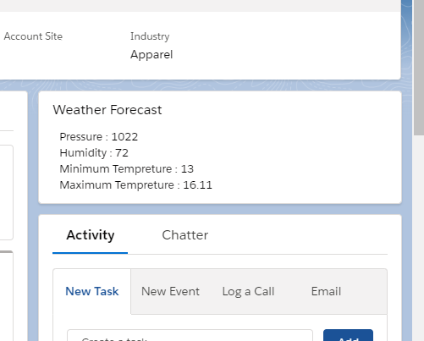

**Reference:** [**https://focusonforce.com/integration-and-data-loading/rest-api-using-weather-example/**](https://focusonforce.com/integration-and-data-loading/rest-api-using-weather-example/)